**OCEANA COUNTY 4-H MARKET LIVESTOCK**

**EDUCATIONAL NOTEBOOK/RECORD**

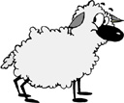

#### LITTLE BUDDY LAMB PROJECT - 2024

## AGES 5 – 7 YEARS

As a member of the 4-H Market Livestock Little Buddy Lamb Project, you are required to submit your records as part of an educational notebook project in order to show your animal at the Oceana County Fair. This notebook must be shown to the Oceana County 4-H Market Livestock Committee’s Weighmaster at the time of weigh-in and then entered by you in the Educational Notebook Division of the Oceana County Fair on Entry Day.

## AGE _________

The age you enter depends on how old you are on or will be on January 1, 2024

**NUMBER OF YEARS IN PROJECT** ________

Use this sheet as the first page of your project record book. Fill it out completely.

**Please print or type neatly.**

NAME _________________________________________________________________

4-H CLUB _______________________________________________________________

BREED _________________________________________________________________

LAMB’S NAME ___________________________________________________________

# NAME OF BIG BUDDY ____________________________________________________



**JUDGE’S SCORE/COMMENT SHEET**

**(PLEASE DO NOT REMOVE, PLACE THIS SHEET IN SHEET PROTECTOR OR GLUE TO COVER). This sheet must be keep free to the judge to write their comments.**

This sheet should help each 4-H’er understand their ribbon placing.

A. **Specific educational value or worth**

___ All questions were answered completely

___ All calculations were correct

___ Calculations were incorrect

___ Questions were not answered (missed questions)

B. **Notebook contains all project records**

___ Notebook contained all project records and were fully completed

___ Notebook contained additional project related information (research

materials etc.)

___ Project records were incomplete

___There was no additional project related information

C. **Accuracy, neatness and general appearance**

___Notebook was neat in appearance (typed/hand printed)

___Notebook pages were clean and stain free

___Notebook pages were in order and complete

___Notebook was difficult to read and messy

__Notebook had wrinkled and stained pages

Other Comments: ______________________________________________________

____________________________________________________________________

**__________________________________________________________________**

# **LITTLE BUDDY LAMB NOTEBOOK**

**TABLE OF CONTENTS**

*Please keep your notebook in Table of Contents order.*

GENERAL GUIDELINE INFORMATON

ABOUT YOUR LAMB

JOURNAL OF CARE

PROJECT INFORMATION & MARKETING

SPECIFIC PROJECT KNOWLEDGE

Lamb Parts

General Lamb-Multiple Choice

Fitting & Showmanship- True or False

YOUR PROJECT INFORMATION

a. My 4-H Project

b. What Does Not Belong

c. Character

d. What Does Your Lamb Need

e. 4-H Knowledge

6) PICTURES OF YOUR PROJECT (1 page)

7) CLUB POINT SHEET

APPENDIXES (OPTIONAL):

PICTURES OF YOUR PROJECT (additional pictures)

FEED INFORMATION (example: feed labels)

ADDITIONAL INFORMATION ABOUT YOUR PROJECT

Information you found in reference materials

Information you located off the internet

Information from your feed representative

Any other information

*\* Include notes as to why you researched this information and*

*found it valuable, link it to your project if possible.*

Notebook Resources:

4-H Skills for Life Animal Series – Sheep 1, 2 & 3

(All lamb leaders have a set of these booklets. There is also a set available on a check-out system at the

MSU Extension Office)

Your Sheep – A Kid’s Guide to Raising & Showing (National 4-H Supply)

Lamb Showmanship Handout – MSU Extension

Kansas State 4-H Online Website

2024-Little Buddy Lamb Notebook (5-7) Page 1

This record book is part of your 4-H Market Lamb Project. By keeping records up-to-date you will be able to see how much progress you make as you set goals and work to accomplish them. Write neatly and clearly. Feel free to add extra pages.

**FAIR ENTRY RULES**

If you are between the ages of 5 and 8 years old and elect to participate in a 4-H class at the Oceana County Fair you will be awarded a participation ribbon for your efforts.

In order to compete for an “A”, “B” or “C” Ribbon you will have to enter you record book in the “Open Educational Notebook Class”.

If you have questions, please contact your leader or the MSU Extension Office as fair approaches.

#### PROJECT PICTURES

Pictures are a required part of this notebook. Taking pictures of your project animal throughout the project will indicate how your animal has grown and developed. Add pictures to your notebook on a separate piece of paper.

#### SCORING CRITERIA

The following breakdown will be used during the judging process of all market livestock notebooks.

A. Specific educational value or worth **30%**

B. Creative way of showing what has been learned **10%**

C. Notebook contains all project records **50%**

D. Accuracy, neatness and general appearance **10%**

**The Oceana County 4-H Market Livestock Committee encourages 4-H Leader and parent assistance with your project and project notebook**. If you should have any questions, please contact the MSU Extension Office.

***If a parent or leader helped you in filling out your notebook*** please have them sign below that the answers are YOUR answers and that they assisted you in the writing of the answers and understanding of the questions only.

_________________________________ _______________________

Signature of person helping with notebook Signature of 4-H Member

**IF written help is needed**

### 2024- Little Buddy Lamb Notebook (5-7) Page 2

**ABOUT YOUR LAMB**

My Lamb’s name is: ___________________________________________

My Lamb’s breed is: ___________________________________________

What color is your Lamb? ______________________________________

My Lamb’s favorite thing to do is? ________________________________

**My Lamb is a** (circle one) **Wether** (boy lamb) **Ewe** (girl lamb)

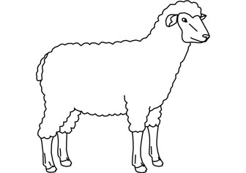

### 2024- Little Buddy Lamb Notebook (5-7) Page 3

**ANIMAL CARE AND MANAGEMENT- JOURNAL OF CARE**

Your project requires regular care and management.

Include the following:

* Walking and working with your animal
* Feeding and watering practices
* Grooming (clipping, toenail trimming, washing, etc.)
* Health practices and medicines (vaccinations, etc.)
* General Management (cleaning living area, feed pans, etc.)

|  |
| --- |
| **Daily- Things done once or twice a day** |
|  |
| **Weekly- Things done once or twice a week** |
|  |
| **Monthly- Things done once a month** |
|  |
| **Yearly- Things done one time or occasionally throughout the year** |
|  |

*My little buddy helped me with the care and training of our project animal.*

Signature of Big Buddy:___________________________________ Date: ____________

2024- Little Buddy Lamb Record Book (5-7) Page 4

**PROJECT INFORMATION**

The start of the project will be the date the 4-Her placed the animal on feed, not any later than June 1st of the current year. The end of the project will be weigh-in day at the Fair.

Project Start Date __________________ Project End Date ________________

What month was your lamb born? _________________________

Please complete the following chart about your project. Have your big buddy help you.

|  |  |  |  |  |  |  |  |
| --- | --- | --- | --- | --- | --- | --- | --- |
| Ear Tag  Number | Breed | Gender | Date of Purchase | Price or Value | Estimated  Starting Weight | Ending Weight | Total Pounds Gained |
|  |  |  |  |  |  |  |  |

**Note: Total pounds gained = ending weight – starting weight**

**MARKETING**

One of the most important parts of any market animal project is marketing. This may include writing letters and talking to prospective buyers. Color in the face, a smiling face is a good action, a frowning face is a bad action. (see the example)

**Good Marketing Practice Poor Marketing Practice**









































Send a picture to your potential buyers

Send a reminder to attend the auction

Let an adult talk to the buyer instead of you talking to them

Know what kind of feed you used if asked

Only go to grocery stores or the banks

Make sure to visit your previous buyers

Only thank those who agree to be listed as a potential buyer

Insult competitors

### 2024- Little Buddy Lamb Notebook (5-7) Page 5

**LAMB PARTS**- Color the lamb parts

Breast- Green Fore shank- Purple Neck- Black

Face- Blue Leg- Yellow Rack- Pink

Flank- Orange Loin- Red Shoulder- Yellow

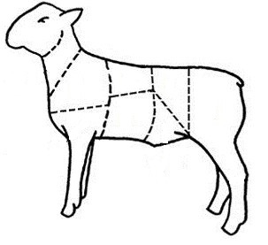

2024- Little Buddy Lamb Notebook (5-7) Page 6

## Lamb Multiple Choice Questions

Circle the correct answer.

1. The best footwear to wear when showing a lamb.

1. Flip flops
2. Boots
3. Athletic shoes
4. Sandals

2. A livestock feed made from grasses that have been cut and dried.

1. Hay
2. Corn
3. Ice cream
4. Broccoli

3. The nose of the lamb is called?

1. Snout
2. Nose
3. Muzzle
4. Beak

4. Which of the following items are used when showing a lamb?

1. A cane
2. A show stick
3. A saddle
4. None of the above

5. Which of the following are sheep By-products?

a. Glue

b. Gelatin

c. Bone

d. All of the Above

6. Which is not a breed of sheep?

a. Dorset

b. Duroc

c. Hampshire

d. Suffolk

2024- Little Buddy Lamb Notebook (5-7) Page 7

**Lamb Fitting & Showing**

(True or False, Circle T for True or F for False)

1. To lead your sheep, you should place one hand under the jaw,

keep the head up & alert, and put the other hand on the dock T F

or behind the ears?

2. If you need to, you can hold the lamb by its fleece to control it? T F

3. You should feed & water your sheep lightly at least a couple

of hours before the show T F

4. It is okay if your lamb is still wet from washing it when you take it T F

Into the show ring?

5. You may wear tennis shoes when showing your lamb? T F

6. When setting your lamb always set the legs closest to the judge first? T F

7. Always keep both eyes on the judge at all times, do not worry about T F

what your animal is doing?

8. When the judge goes to handle your lamb make sure to “brace” it? T F

9. Do not try to pull into line ahead of another exhibitor, the judge T F

does not like to see people who are not courteous?

10. If you do not agree with the judge it is okay to tell them they are wrong? T F

11. You should wear a hat when showing to keep the sun out of your eyes? T F

12. Always say thank you to the judge and congratulate the winner? T F

13. It does not matter where you place as long as you did your very

best, had fun and learned something. You should be very proud of T F

yourself?

14. Be ready to answer questions about your project. The judge may ask

questions about your animal and the sheep industry to find out what T F

you have learned from your 4-H lamb project?



2024- Little Buddy Lamb Notebook (5-7) Page 8

**YOUR PROJECT**

Please answer the following questions to the best of your ability.

1. What did you have the most fun doing with your project?

______________________________________________________________________________________

______________________________________________________________________________________

______________________________________________________­­­­­­­­________________________________

______________________________________________________________________________________

2. What was the hardest part of your project?

______________________________________________________________________

______________________________________________________________________

_____________________________________________________________________________________

_____________________________________________________________________________________

3. Will you do a lamb project again?

____________________________________________________________________________________

Why or why not?

_____­­­­­­_____________________________________________________________­­­­­­___________________­­­­­­

­­­­­­­­

____________________________________________________________________________________

_____________________________________________________________________________________

_____________________________________________________________________________________

2024- Little Buddy Lamb Notebook (5-7) Page 9

**What Does Not Belong?**

In each statement one word does not belong, *X (cross)* out that word.

1. Sheep have: beaks, muzzles, eyes, ears

2. Sheep eat: grass, water, glue, pellets

3. The people who help me take care of and learn about my swine are:

my parents, the veterinarian, the mailman, my club leader

4. Sheep breeds: Hampshire, Suffolk, Berkshire, Oxford

**Identify Good & Bad Character Actions**

Color in the face, a smiling face is a good action, a frowning face is a bad action. (see the example)

**RAISING and SHOWING an RAISING and SHOWING an**

**ANIMAL *with* CHARACTER ANIMAL *without* CHARACTER**









































Feed Animals on Time

Complain about the judge

Clean pens daily

Thank the judge for their time

Congratulate whoever places first

Ask for help

Leave animals outside without shelter

Help others if asked

Complete your record book honestly

Insult competitors

2024- Little Buddy Lamb Notebook (5-7) Page 10

**WHAT DOES YOUR LAMB NEED?**

**(have an adult help you read the following & then circle those items**

**that your lamb needs below)**

All living creatures need certain things to survive, like food, *water* and shelter. What sheep need depends a lot on how old they are. Newborn lambs need colostrum, *milk* from their mothers, and lots of *shelter* from the cold. As lambs grown older, they drink less milk and start eating more of the types of feed that adult sheep eat. In the spring, summer and fall most sheep are on pasture and eat grass. In the wintertime, there is no grass so they are fed hay. Some sheep require more nutrients at times, when they are growing or producing milk for example. They are then fed whole grains such as barley or *corn* or a concentrate ration. Concentrate rations include, grain, minerals, vitamins and sometimes a protein supplement. All sheep need clean *water* and *shelter* from bad weather. All sheep like having dry straw to lie on in the winter to keep them warm and clean. *Farmers* take care of their sheep to make sure they are healthy and comfortable. If any sheep are sick the farmer will treat them with the help of the *veterinarian*. (*Activity Found on Ontariosheep.org)

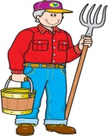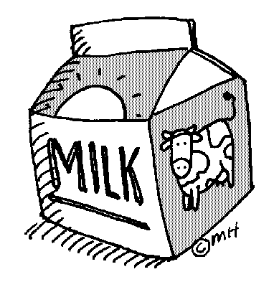

BARN

FARMER

BIKE

JUICE

WATER

CLOTHES

MILK

CORN

VETERINARIAN

TV

CAKE

2024- Little Buddy Lamb Notebook (5-7) Page 11

**4-H KNOWLEDGE**

**The 4-H Pledge**- *Draw a line to the picture that fills in the blank* (see the example)

***I pledge…***

HANDS

HEALTH

HEAD

HEART

WORLD

COUNTRY

CLUB

COMMUNITY

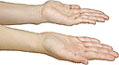









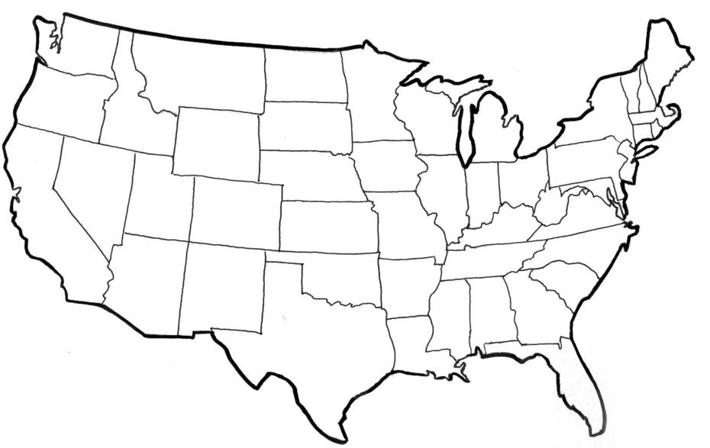

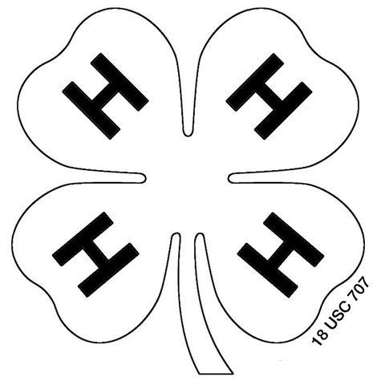



My ____________ to clearer thinking,

My ____________ to greater loyalty,

My ____________ to larger service, and

My _____________ to better living,

for my ____________________,

my _______________________,

my _______________________,

and my ____________________.

###### 

2024- Little Buddy Lamb Notebook (5-7) Stamp _______________

PAGE 12 Staff ________________

**4-H MARKET LIVESTOCK POTENTIAL BUYER’S LIST**

**LAMB PROJECT (AGES 5-7)**

Name______________________________ Club_________________________

***Please print business names and complete addresses clearly.***

* 1. Contact Name ________________________________________________­­____

Business Name ____________________________________________________

**Mailing** Address _________________________City__­­­­­­­­__­­­­­­­_____________Zip_____

Phone _______________________ After Hours Phone______________________

Mailing Preference (Please Check One): Email ____ Postal Delivery ____

Email ____________________________________________________________

Signature__________________________________________________________

2. Contact Name ________________________________________________­­____

Business Name ____________________________________________________

**Mailing** Address _________________________City__­­­­­­­­__­­­­­­­_____________Zip_____

Phone _______________________ After Hours Phone______________________

Mailing Preference (Please Check One): Email ____ Postal Delivery ____

Email ____________________________________________________________

Signature__________________________________________________________

3. Contact Name ________________________________________________­­____

Business Name ____________________________________________________

**Mailing** Address _________________________City__­­­­­­­­__­­­­­­­_____________Zip_____

Phone _______________________ After Hours Phone______________________

Mailing Preference (Please Check One): Email ____ Postal Delivery ____

Email ____________________________________________________________

Signature__________________________________________________________

(Must be stamped by the MSU Extension Office)

2024- Little Buddy Lamb Record Book (5-7) Stamp _______________

PAGE 13 Staff ________________

**If you would like to contact additional buyers you can use this page. If not please throw this page out.**

Contact Name ________________________________________________­­____

Business Name ____________________________________________________

**Mailing** Address _________________________City__­­­­­­­­__­­­­­­­_____________Zip_____

Phone _______________________ After Hours Phone______________________

Mailing Preference (Please Check One): Email ____ Postal Delivery ____

Email ____________________________________________________________

Signature__________________________________________________________

Contact Name ________________________________________________­­____

Business Name ____________________________________________________

**Mailing** Address _________________________City__­­­­­­­­__­­­­­­­_____________Zip_____

Phone _______________________ After Hours Phone______________________

Mailing Preference (Please Check One): Email ____ Postal Delivery ____

Email ____________________________________________________________

Signature__________________________________________________________

Contact Name ________________________________________________­­____

Business Name ____________________________________________________

**Mailing** Address _________________________City__­­­­­­­­__­­­­­­­_____________Zip_____

Phone _______________________ After Hours Phone______________________

Mailing Preference (Please Check One): Email ____ Postal Delivery ____

Email ____________________________________________________________

Signature__________________________________________________________

2024- Little Buddy Lamb Record Book (5-7) PAGE 14

**YOUR PROJECT PICTURES**

(Please use this page for your project pictures and tell anything special, that you might want the judge to know, about you and your project animal.

**NON-CLUB POINTS**

**8 YEARS OLD & UP MUST COMPLETE- MARKET LIVESTOCK ANIMAL ASSOCATION PROJECT ATTENDANCE RECORD**

***(This must be filled out before presenting for signatures at the office.)***

|  |  |  |  |  |
| --- | --- | --- | --- | --- |
| **MEETING NAME** | **LOCATION** | **DATE** | **POINTS** | **SIGNATURE OF LEADER, SUPERINTENDENT OR MSU STAFF** |
| LG. MKT Annual Meeting | West Michigan Research Station | 10/23/22 | 1 |  |
|  |  |  |  |  |
|  |  |  |  |  |
|  |  |  |  |  |
|  |  |  |  |  |
|  |  |  |  |  |
|  |  |  |  |  |
|  |  |  |  |  |
|  |  |  |  |  |
|  |  |  |  |  |
|  |  |  |  |  |
|  |  |  |  |  |

Please note: This form must be included with your record notebook and turned into the weigh master on entry day of the Fair. You need to accumulate **nine (9) points** to be allowed to sell your animal. **Six (6)** of these **nine (9) points** must come from club meetings. The **three (3)** non-club points must be earned from attending various 4-H events and activities. See your leader, the MSUE office, or online at <https://www.canr.msu.edu/oceana/oceana_county_4_h/oceana_4_h_market_livestock> for a listing of approved nonclub points.

**CLUB POINTS**

**MARKET LIVESTOCK ATTENDANCE RECORD- ALL AGES MUST COMPLETE**

***(This must be filled out before presenting for signatures at the office.)***

|  |  |  |  |  |
| --- | --- | --- | --- | --- |
| **MEETING NAME** | **LOCATION** | **DATE** | **POINTS** | **SIGNATURE OF LEADER, SUPERINTENDENT OR MSU STAFF** |
|  |  |  |  |  |
|  |  |  |  |  |
|  |  |  |  |  |
|  |  |  |  |  |
|  |  |  |  |  |
|  |  |  |  |  |
|  |  |  |  |  |
|  |  |  |  |  |
|  |  |  |  |  |
|  |  |  |  |  |
|  |  |  |  |  |
|  |  |  |  |  |
|  |  |  |  |  |
|  |  |  |  |  |
|  |  |  |  |  |

Please note: This form must be included with your record notebook and turned into the weigh master on entry day of the Fair. You need to accumulate **nine (9) points** to be allowed to sell your animal. **Six (6)** of these **nine (9) points** must come from club meetings. The **three (3)** non-club points must be earned from attending various 4-H events and activities